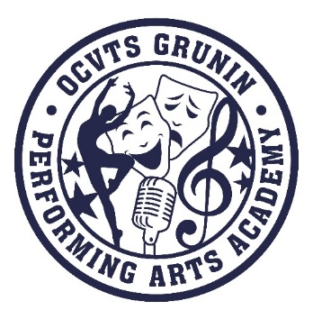
OCVTS GRUNIN PERFORMING ARTS ACADEMY
Parent Teacher Student Organization (PTSO)

Membership Form 2023 -2024
Annual Fee - $10

Name: __________________________________________________________________

Phone: _________________________________________

email: ______________________________________________________________

Mailing Address: ______________________________________________________________

______________________________________________________________

Student’s Name: _____________________________________________________________

CLASS: Fr Soph Jr Sr MAJOR: Acting Audio Vocal Dance

Student’s Name: ______________________________________________________________

CLASS: Fr Soph Jr Sr MAJOR: Acting Audio Vocal Dance

Payment Method: $10
Cash_________ Check#_________ (Please make checks payable to: GPAA PTSO)

Credit Card: Cheddar Up Link _______ (To pay by cc – updated link will be available on the “Member Page” of GPAA PTSO website www.paaptso.org after 9/6/23)

Membership form and payment can also be returned by your student to the school office or by mail. Please be sure to note on envelope “GPAA PTSO Membership”

Grunin Performing Arts Academy
Attn: PTSO
1 College Drive, Bldg #12
Toms River, NJ 08754

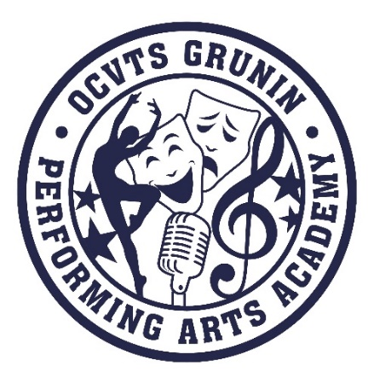
OCVTS GRUNIN PERFORMING ARTS ACADEMY
Parent Teacher Student Organization (PTSO)

General Membership Information

The Grunin Performing Arts Academy PTSO would like to welcome all the new students, returning students and their families to the 2023 – 2024 school year. We hope you had a relaxing and wonderful summer! Parents, students and teachers are encouraged to join and participate in the PTSO because your time and talent helps us to successfully raise funds that support many programs for each grade and major.
  - Our Annual Membership Dues are only $10 per family.
- One benefit of PTSO membership is that your student will be eligible to apply for a GPAA Scholarship in their Senior Year. The only requirement is a minimum 3 years membership to the PTSO.
- PTSO meetings are held at 7pm on the third Wednesday of each month in the GPAA Black Box Theater. Dates are subject to change due to weather or performance schedules and changes will be posted as soon as possible on our PTSO Facebook and Instagram pages.
- Stay up to date with calendar of events, programs and more on our Website: www.paaptso.org
- Join our Facebook page - OCVTS PAA PTO for current and
up-to-date information
- Join our Instagram page - PAA PTSO
- Questions? Email to paaptsowebsite@gmail.com
- Show your support in a variety of ways! Donate snacks or volunteers to assist at student food service during a tech week, sell concessions or 50/50 tickets at an event, or even attend the many wonderful performances by the acting, dance or vocal majors.

We look forward to seeing you throughout the year and welcome to the GPAA PTSO!

